OUTPUTS :

GCD USING RECURSION

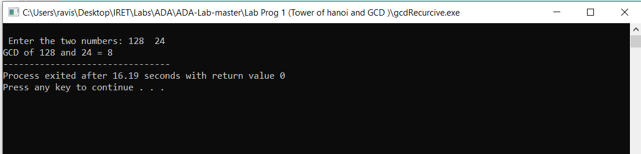

TOWER OF HANOI

